Plant health biosecurity for conservation - assessments and implementation in natural habitats

Plant health biosecurity plan
Introduction
This plant health biosecurity planning template for conservation work aims primarily to prevent the introduction and spread of non-native / alien plant pests and pathogens, which include: bacteria, fungi, insects, mites, nematodes, oomycetes, phytoplasmas, viruses and viroids – these organisms can be damaging to plants and are collectively referred to as plant pests. Most plant pest biosecurity measures should also help prevent the spread of all unwanted organisms, e.g. Invasive Non-Native Species (INNS) as well as all pests and diseases of plants. All unwanted organisms, if introduced or spread further, have the potential to cause extensive damage to plant life and associated ecosystems, making robust biosecurity measures crucial for maintaining the health of plants that grow in semi-natural habitats and all other landscapes.
Carrying out plant conservation work (e.g., habitat maintenance and management, plant relocations, plant translocations, habitat creation, habitat restoration) carries a risk of the inadvertent introduction of plants pests into sensitive habitats - thereby negating the objectives of the work. Every phase of the process for planned works needs to be assessed for biosecurity risks, this can include, for example: the production of plants; planting at the restoration site; movement of people and tools; and the movement of machinery and soil. There may be project specific factors to consider and the framework in this template aims to support practitioners develop an effective plant health biosecurity plan for their site(s) and conservation operations. Populated example forms can be found in Appendix B of this document.
Key aspects covered in this planning template:
Prevention versus managing pests - The focus of this plan is to be proactive and prevent the introduction and/or spread of plant pests in the first instance, i.e. ‘prevention is better than cure’
Pathway analysis – The objects (e.g. live plants) and/or means of travel (e.g. via wind or water course) that can lead to pests arriving in a new area are known as pathways. A method of assessing threats from plant pests is to consider all potential pathways which in turn enables the implementation of key plant health biosecurity measures for the site(s) where conservation work is to be carried out.
Specific plant pests of concern - It can be an intensive exercise to identify and assess every notifiable plant pest relevant to proposed conservation works. However, in certain situations it will be necessary to identify specific plant pests that present a high risk. This plan aims to assist practitioners identify when individual plant pest species should be included as part of a plant health biosecurity plan.
Measures that protect against all unwanted organisms - Often notifiable plant pests and Invasive Non-Native Species (INNS) are considered separately when in reality many of the measures that prevent the spread of plant pests will also help prevent the spread of INNS. Ultimately the aim of this plan is to support good biosecurity systems to prevent the spread of all unwanted organisms, such as micro-organisms, invertebrates, nematodes, as well as plant life, aquatic organisms and mammals.
Known and unknown pests - It is acknowledged that there are many organisms that we know we must avoid spreading, however, there are also potentially damaging organisms that as of yet we do not know about. Therefore, robust biosecurity measures to protect against all unwanted organisms are essential to environmental stewardship.
Site ownership and responsible person(s)
Site owner/organisation
Name and job title of person filling in this assessment / name of person responsible for overseeing all site operations (if different)
Phone number(s) of above
Email (s) of above
Designated biosecurity manager (person responsible):
Phone number of biosecurity manager
Email of biosecurity manager
Site location
Site name:
Site Address (if available)
National grid reference coordinates:
Plan dates
It is recommended that the first review should be no longer than one-year after sign-off date by the senior manager
Date of plan preparation:
Signed off by (senior manager)
Review date

Organisation’s Plant Biosecurity Policy / Approach
Provide details of the organisations approach to plant biosecurity
(e.g. a policy or a statement recognising the threat from non-native / alien plant pests in relation to the work of the organisation)
If your organisation does not have a plant biosecurity policy or an official approach, then completing this template and accessing the associated resources aims to provide a substantive first step.

Project Description
General description of the site and nature of works to be conducted – if helpful a plan / map can be appended to the plan

Site designations
Select all relevant site designations here and add any site-specific information of relevance to this plan, i.e. which may inform management responses
Designation (types of protected areas) | Yes / No | Plant health and biosecurity considerations
RAMSAR site
Special Area of Conservation (SAC)
National Nature Reserve (NNR)
Site of Special Scientific Interest (SSSI)
Local Nature Conservation Site (LNCS)
Local Nature Reserve (LNR)
National Park
Other Effective Conservation Measure (OECM)
Other

Managing biosecurity risks associated with the movement of plants and soils
Add below the activities which you propose to carry out with respect to the movement of plant and soil and how you are going to reduce the biosecurity risks associated with your work. An example is given. Use the framework within the PHC Biosecurity Best Practice Guide for Conservation to assess risk level and worked example (see Appendix A).
Inherent within this table is the assumption that any introduction of a novel pest and diseases / unwanted organisms into a new area will have a high (negative) ecological impact (i.e. it takes a precautionary principle to the introduction of unwanted organisms).
Activity to be carried out | Assessed risk level  Low/Medium/High | Risk minimisation measures including a description of how this minimises the risk. | Risk level after mitigation measures implemented
EXAMPLE  Translocation of plants from nursery to field (planting) site. | High – moving mature plants long distances with growing media attached is high risk (see table on pg 2 of best practice guide) | (1) Plant used have been grown in a nursery with a high standard of plant biosecurity and independently audited.  (2) plants sourced from a local nursery to minimise risk of moving a pest afar.  (3) The risk has been reduced further by using bare-root transplants to minimise the risk of introducing pests or pathogens in growing media. | Low
Continue to add rows until all risks are identified | To complete
Managing biosecurity risks associated with the movement of machinery and equipment used for operations on the site
Add below the activities which you propose to carry out in relation to the movement of machinery and equipment used for operations on the site and how you are going to reduce the biosecurity risks associated with your work. An example is given. Use the framework within the PHC Biosecurity Best Practice Guide for Conservation to assess risk level (see Appendix A)
Inherent within this table is the assumption that any introduction of a novel pest and diseases / unwanted organisms into a new area will have a high (negative) ecological impact (i.e. it takes a precautionary principle to the introduction of unwanted organisms).
Activity to be carried out | Assessed risk level  Low/Medium/High | Risk minimisation measures including a description of how this minimises the risk. | Risk level after mitigation measures implemented
EXAMPLE  Bringing a JCB onto a peatland restoration site shape peatland edges and ditches. | High – machinery can transport pests and pathogens if soil is attached from last site. | Thoroughly clean the machinery to remove all visible soil | Low
Continue to add rows until all risks are identified |  | To complete
Managing ongoing biosecurity risks associated with site management
Add below the activities which you propose to carry out in relations to site management (e.g., beating-up, checking fences, visitor management, etc.) and how you are going to reduce the biosecurity risks associated with you work. An example is given. Use the framework within the PHC Biosecurity Best Practice Guide for Conservation to assess risk level (see Appendix A)
Inherent within this table is the assumption that any introduction of a novel pest and diseases / unwanted organisms into a new area will have a high (negative) ecological impact (i.e. it takes a precautionary principle to the introduction of unwanted organisms).
Activity to be carried out | Assessed risk level  Low/Medium/High | Risk minimisation measures including a description of how this minimises the risk. |  | Risk level after mitigation measures implemented
EXAMPLE  Site or contractors entering the site on foot | High – pests and pathogens can be spread on footwear | Clean the treads of boots/footwear  Inspect the laces, inner sole, folds and flaps of footwear to make sure there is no soil or seeds present. |  | Low
Continue to add rows until all risks are identified |  | To complete

Plant pests of concern to project
Use this box to cover any specific pests that are of concern and why they are a threat.
Some examples of specific pests that are of concern in Scotland are: Phytophthora (P. alni) disease of alder; Oak processionary moth (Thaumetopoea processionea); Blueberry rust fungus (Pucciniastrum minimum); Phytophthora (P. ramorum and P. kernoviae) disease of vaccinium (blue berry or blaeberry); Dothistroma needle blight (D. septosporum) of pine. Thought should be given to the wider context of conservation work, e.g., if your work is focussed on restoring twinflower in a Caledonian Pinewood, pine diseases should also be considered as a concern because these could still be inadvertently introduced with twinflower.

Other unwanted organisms of concern to this project (e.g. INNS)
List named species here that are to be considered during the development of this biosecurity plan.
Some examples of unwanted organisms that are of concern in Scotland are: - Rhododendron (Rhododendron ponticum); Japanese knotweed (Fallopia japonica); Purple pitcher plant (Sarracenia purpurea) in some areas; Non-local heather (Calluna vulgaris) genotypes.

Plant pest monitoring during works
List monitoring methods and frequencies below (detection survey)
Method of monitoring | Frequency of checks

Plant pest monitoring post-completion of works
List monitoring methods and frequencies below (detection survey)
Method | Frequency

People – Awareness
Clear instructions and training are central to good biosecurity practice – use this table to identify the groups of stakeholders to engage with and the training and/or information that should be provided to each person or group.
People and stakeholders | Training provided / guidance or information issued in particular taking account of any risks to biosecurity identified
Site manager
Staff
Contractors
Visitors
Others

Incursion / outbreak response
Detail the procedures to be followed in the event that a plant pest or other unwanted organism is detected (this could include time scales, responsible person to lead response, resources required, licences required etc.). Pest concerns should be reported to SASA’s Horticultural & Marketing Unit (hort.marketing@gov.scot).

Record keeping
List records that will be kept as part of the Plant Health Biosecurity Plan (e.g. plant passports, good in checks)

Resource section
Plant Health Centre biosecurity best practice guide for conservation https://www.planthealthcentre.scot/sites/www.planthealthcentre.scot/files/2024-05/Biosecurity%20best%20practice%20for%20conservation%20WEB.pdf
Plant Health Centre biosecurity best practice for safe disposal of plant waste and spent growing media https://cdn.forestresearch.gov.uk/2023/05/Plant-waste-guidance.pdf
Detailed Pest Fact Sheets for 39 Priority Pests https://www.planthealthcentre.scot/sites/www.planthealthcentre.scot/files/2025-05/39%20Priority%20Pest%20Factsheets.pdf
Symptoms of Ill Health in Plants: An Introductory Guide for the Horticultural Sector https://cdn.forestresearch.gov.uk/2023/05/Symptoms-of-ill-health-in-plants-flier.pdf
Reducing Phytophthora risk in nurseries – key considerations https://cdn.forestresearch.gov.uk/2023/05/Reducing-Phytophthora-risk-in-nurseries-flier.pdf
Understanding high risk hosts for Phytophthora https://cdn.forestresearch.gov.uk/2023/05/High-risk-hosts-for-Phytophthora-flier.pdf
Defra UK Plant Health Information Portal https://planthealthportal.defra.gov.uk/
The UK Plant Health Risk Register https://planthealthportal.defra.gov.uk/pests-and-diseases/uk-plant-health-risk-register/
Reporting tree related health issues to Forest Research Tree alert: https://treealert.forestresearch.gov.uk/
For Northern Ireland, use Tree Check https://www.treecheck.net/twa-ui/#/public/report
Detailed tree pest and disease information is available on the Forest Research pest and disease resources pages https://www.forestresearch.gov.uk/tools-and-resources/fthr/pest-and-disease-resources/
Tree Health Centre Resource Hub (Yorkshire Arboretum) https://www.yorkshirearboretum.org/treehealthresourcehub

Glossary of terms
ISPM 5 – Glossary of phytosanitary terms
Detection survey: Survey conducted to determine the presence or absence of pests [FAO, 1990; revised FAO, 1995; CPM, 2022]
Incursion: An isolated population of a pest recently detected in an area, not known to be established, but expected to survive for the immediate future [ICPM, 2003]
Outbreak: A recently detected pest population, including an incursion, or a sudden significant increase of an established pest population in an area [FAO, 1995; revised ICPM, 2003]
Pest risk assessment (as opposed to Analysis): valuation of the probability of the introduction and spread of a pest and the magnitude of the associated potential economic consequences [ISPM 2, 1995; revised ISPM 11, 2001; ISPM 2, 2007]

References
Kline, N., Elliott, M., Parke, J.L., Stark, D., Shaw, D.C. and Christiansen, A., 2022. Preventing Phytophthora Infestations in Restoration Nurseries: A Key to Protecting Wildland Plant Communities. Oregon State University Extension Service. https://extension.oregonstate.edu/catalog/pub/em-9330-preventing-phytophthora-infestations-restoration-nurseries
Disclaimer
The aim of this template is to support conservation practitioners and managers to demonstrate that they have considered and mitigated the biosecurity risks associated with the work they intend to carry out in the natural environment. The use of this template does not provide comprehensive evidence that all relevant risks have been mitigated for a given site. Please note that the information contained in this template may not cover all risks and users of this template should conduct their own research and assessments into the relevant biosecurity risks for their site and operations.
Appendix A – Plant Health Centre “Biosecurity best practice for conservation” guide
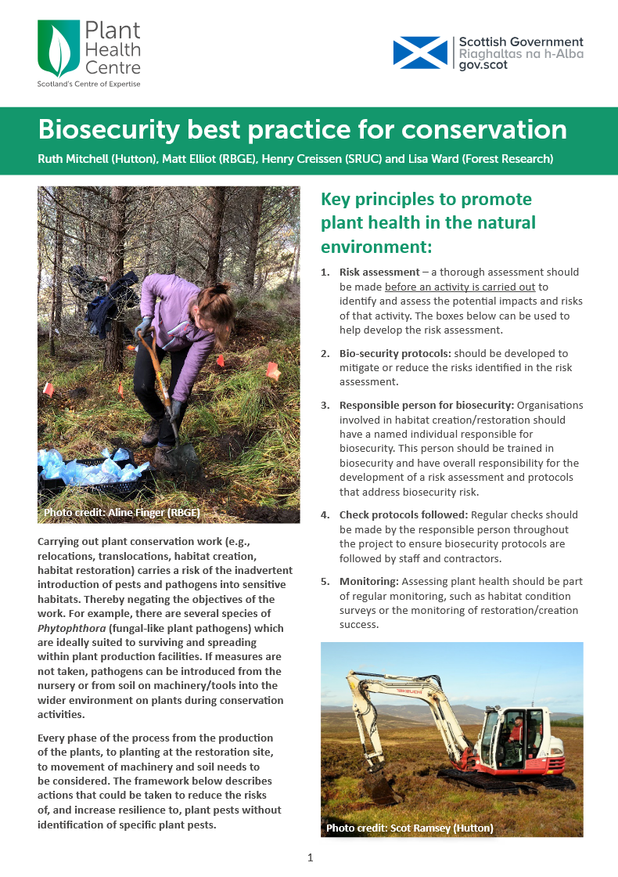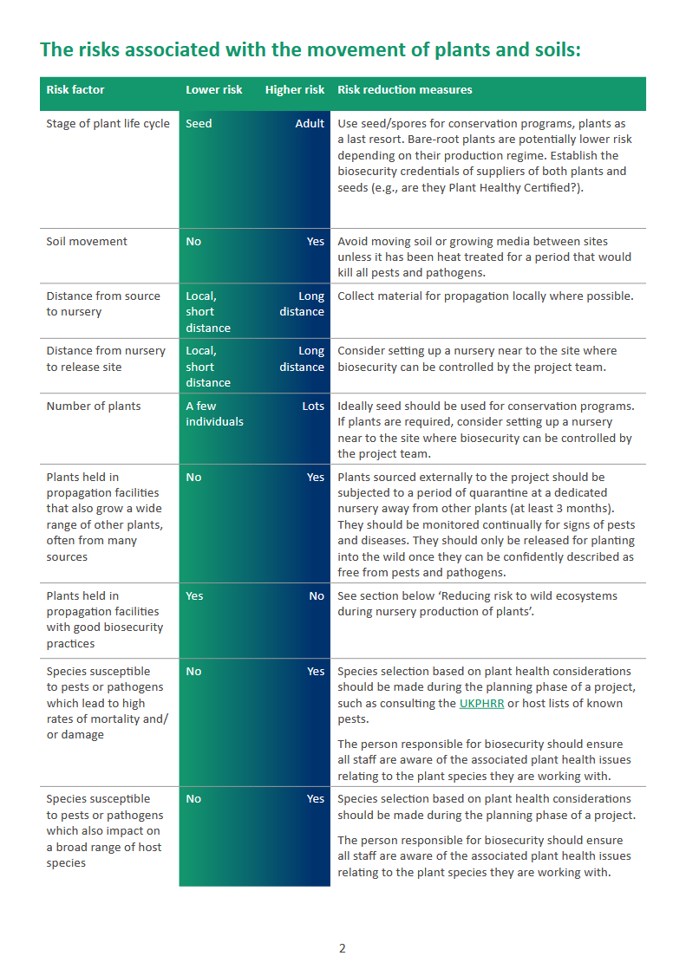
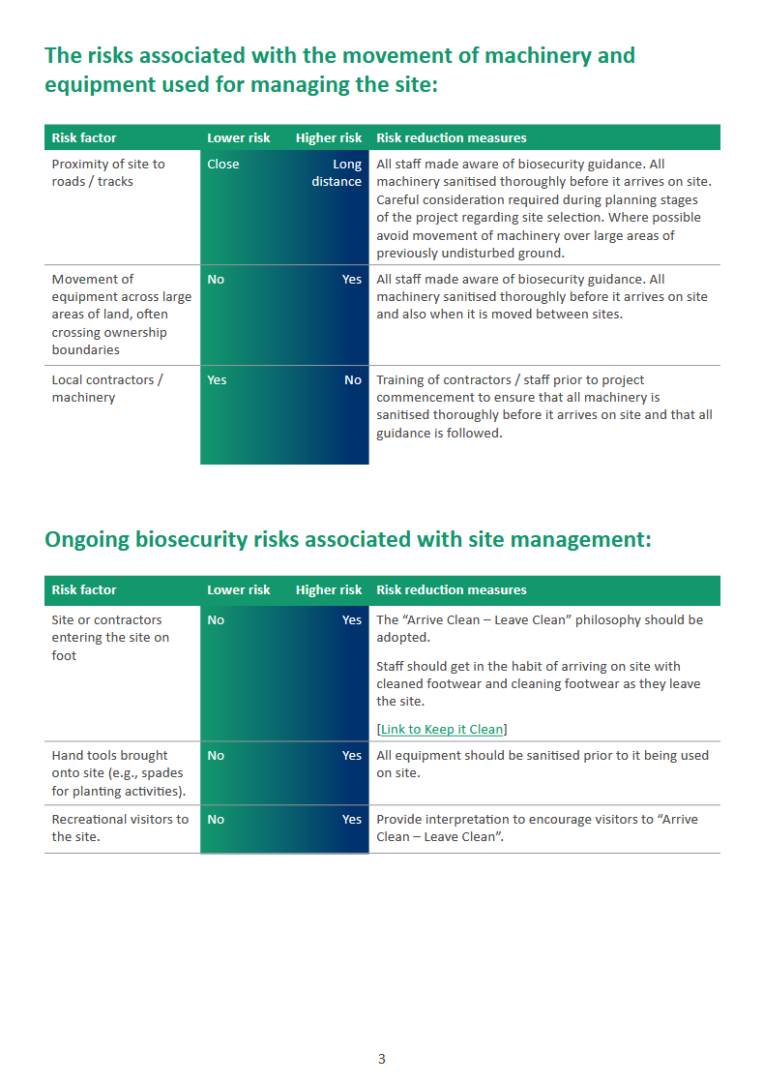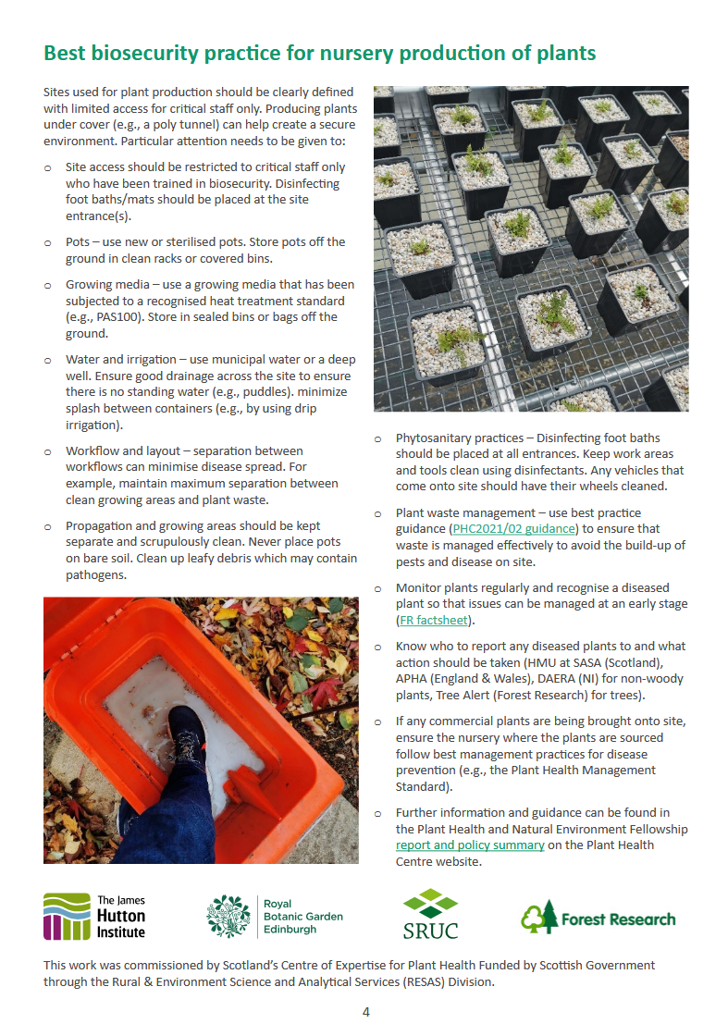

Appendix B – Example Case Studies
To test the PHBP template, two stakeholders were asked to fill out the template as if they were using it for a project or specific application. This helped generate real-world examples to guide future users of the template. These examples are given below as links to PDFs. If you have difficulty accessing them, they are included in Appendix C of the project Final Report, available on the PHC website: Developing resources for appropriate plant biosecurity assessments and implementation in natural habitats | Plant Health Centre

Case study 1 – was completed by a team that is carrying out peatland restoration projects across various sites in Scotland. This shows the use of the PHBP as a general risk assessment tool for a specific activity over a number of sites.
PHC2024-02 Case study 1 - peatland restoration.pdf

Case study 2 – a rare plant project at RBGE concerned with the conservation of a native fern, Woodsia ilvensis. This case study shows the biosecurity considerations required for plant translocations, relocations and habitat creation projects.
PHC2024-02 Case Study 2 - plant translocation.pdf

